Research Process guideline

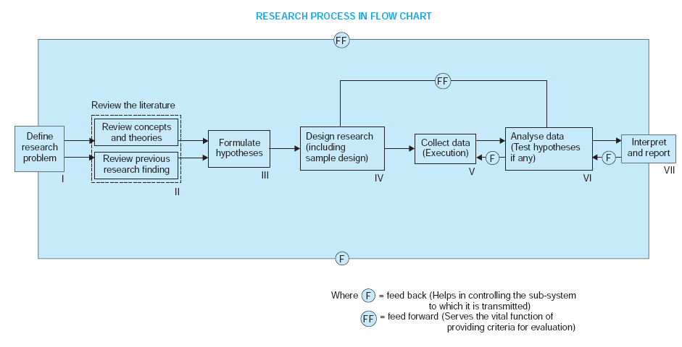

(1)Formulating the research problem;
(2) extensive literature survey;
(3) developing the hypothesis;
(4) preparing the research design;
(5) determining sample design;
(6) collecting the data;
(7) execution of the project;
(8) analysis of data;
(9) hypothesis testing;
(10) generalisations and interpretation,
(11) preparation of the report or presentation of the results ,i. e., formal write-up of conclusions reached.

1. Formulating the research problem:

Two types of research problem:
relate to States of nature,
relate to relationship between variables.
Initially, problem start in a broad general way and then the ambiguities , if any relating to the problem are resolved.
Then feasibility of a particular solution is to considered before a working formualtion of the problem can be set up.
Two steps involved in this phase
1) Understanding the problem.
2) rephrasing the problem into meaningful terms from analytical POV.

2.Extensive Literature Survey
At this juncture the researches should undertake literature survey connected with the problem.

3.Development of working hypothesis
Working hypothesis is tentative assumption made in order to draw out and test its logical or empirical consequences.
To develop a working hypothesis, following approach is taken:
(a) Discussions with colleagues and experts about the problem, its origin and the objectives in seeking a solution.
(b) Examination of data and records, if available, concerning the problem for possible trends, peculiarities and other clues.
(c) Review of similar studies in the area or of the studies on similar problems.
(d) Exploratory personal investigation which involves original field interviews on a limited scale with interested parties and individuals with a view to secure greater insight into the practical aspects of the problem.
4. Preparing the research Problem
After the research problem is formulated, the conceptual structure within which research
Research purposes maybe grouped into 4 categories
1) Exploration 2) Description 3) Dignosis 4) Experimentation
5.Determing Sample Design
Sample design is a definite plan determined before any data are actually collected for obtanining a sample from a given population
Some of the popular sample designs are as follows:
I) Deliberate sampling,
2)Simple random sampling
3)Systematic sampling
4)Stratified sampling
5)Quota sampling
6)Cluster sampling and area sampling
7) Multi-stage sampling
8) sequential sampling

6) Collecting the data:
Data can be collected by any one or more of the following ways:
i)By observation
ii)Through personal interviews
iii)Through telephone interviews
iv) Questionnaries
v)Through schedules
7.execution of project
8. Analysis of data
It requires a no of closely related operation such as establishment of
categories, coding , editing, Tabulation.
After Tabulation is generally based on the computation of various percentages, coefficients, etc. By applying various well defined statistical formulae.
9. Hypothesis – testing
such as chi squared test, t-test, f-test, have been developed by statisticians for this purpose.
Hypothesis-testing will either result in either accepting the hypothesis or rejecting it.
10. Generalizations and Interpretations
11.Preparation of the report or the thesis

Important Concepts Relating to research design
1.Dependent and independent variables:
The variables in a study of a cause-and-effect relationship are called the independent and dependent variables. The independent variable is the cause.Its value is independent of other variables in your study. The dependent variable is the effect. Its value depends on changes in the independent variable
2. Extraneous variables: Independent variables that are not related to the purpose of the study, but may affect the dependent variable are termed as extraneous variable.
3. Control: To minimize the influence or effect of extraneous variable.
4. Confounded relationship: when the dependent variable is not free from the influence of extraneous variable, the relationship between the dependent and independent variable is said to be confounded by an extraneous variable(s).
5.Research hypothesis: when a prediction or a hypothesized relationship is to be tested by scientific methods, its termed as research hypothesis. The research hypothesis is a predictive statement that relates an independent variable to a dependent variable.
6. Experimental and control groups:
In an experimental hypothesis-testing research when a group is exposed to usual conditions, it’s termed as ‘control-group’
When a reseach is exposed to some novel or special condition, it is termed an ‘experimental group’.
7.Treatments: conditions under which experimental and control groups are put are usually referred to as ‘treatments’
8.Experiment: process of examining the truth of a statistical hypothesis, relating to some research problem.

Sampling:
Sampling is a process used in statistical analysis in which a predetermined number of observations are taken from a larger population. The methodology used to sample from a larger population depends on the type of analysis being performed.
The selection process or techniques Is called sample design and the survey conducted on the basis of sample is described as sample survey.
Some fundamental definition:
Sampling frame: The elementary units or the group or clusters of such units may from the basis of sampling process in which case they are called as sampling units.
Sampling design: A sample design is a definite plan for obtaining a sample from the sampling frame.
Statistics and parameters: A statistic is a characteristic of a sample, whereas a parameter is a characteristic of a population.
Sampling error: sample surverys do imply the study of small portion of the population and as such there would be naturally be a certain inaccuracy in the descriptive/info sample collected.
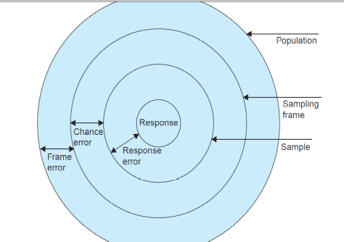
Sampling error = frame error + Chance error + Response

Precision:
Precision is the range within which the population average( or other parameter) willl lie in accordance with the reliability specified in the confidence level as a percentage of the estimate + or – as a numerical quantity.
For instance, if the estimate is Rs 4000 and the precisison described is +- 4%, then the true value will be no less than Rs 3840 and no more than 4160.
Confidence level and significance level:
The confidence level or reliability is the expected percentage of time that the actual value will fall within the stated precision limits
Sampling distribution:
If we take certain number of samples and for each sample compute various statistical measures such as mean, standard deviation,etc . Then we can find that each sample may give its own value for the statistic under consideration
Important sampling distribution:
Some of the important sampling distribution, which commonly used are:
1. Sampling distribution of mean
2. Sampling distribution of proportion
3. Student’s ‘t’ distribution
4. F distribution
5. Chi-square distribution

Sampling Theory
Sampling Theory is a study of relationships existing between a population and samples drawn from the population.
Sampling theory is designed to attain one or more of the following objectives:-
1. Statistical estimation:
The estimate can either be a point estimate or it may be an interval estimate.
2.Testing of Hypothesis:
Is to enable to decide whether to accept or reject hypothesis.
3.Statistical inference:
S.T helps in making generalization about the population/universe from the studies based on the samples drawn from it. It also helps in determing the accuracy of such generalization.

Hypothesis Testing:S
Suppose for a Virus A After taking a preliminary Analysis, People taking Drug A need on average, 13 fewer hours to recover than People taking Drug B is our hypothesis.
We repeat the experiment so many times that it would be hard to imagine that the results were due to random things, like everyone taking taking Drug A has better diet or got more exercise than the people taking Drug B.
After doing all of these repeated experiments, we see the results are the opposite of the original hypothesis. So we can confidently reject the hypothesis that we came up with after doing the preliminary experiments.
Now consider Drug C and Drug D.
Based on preliminary result, we can create a hypothesis about Drug C and Drug D.
Only this Time, we get something I.e only slightly different and in the same direction.
In above figure, our preliminary analysis only said 13 hours cause it was our first test. But this could be easily be 12 hour or 13.5 hours.
Because the results from the repeated experiment arenot different enough to cause us to reject the hypothesis. The best we can do is fail to reject the hypothesis.
Because its unclear if the hypothesis should be based on this 13 hours or 12 hours or 13.5 hours and so on.
So Since the goal is to see if Drug C is different than Drug D.
We simply test test to see if there is no difference between the Drugs. The hypothesis that there is no Difference between two things is called the Null hypothesis.
Null Hypothesis does not require preliminary data because the only value that represent no difference is 0.

Characterisitics of hypothesis:
Hypothesis should be clear and precise.
Hypothesis should be capable of being tested.
Hypothesis should state relationship between variables, if it happens to be a relational hypothesis.
Hypothesis should be limited in scope and must be specific.
Hypothesis should be consistent with most known facts
Hypothesis should be amenable to testing within a reasonable time
Hypothesis must explain the facts that gave rise to the need of explanation.
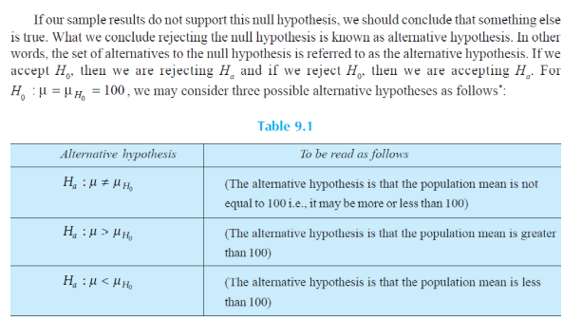

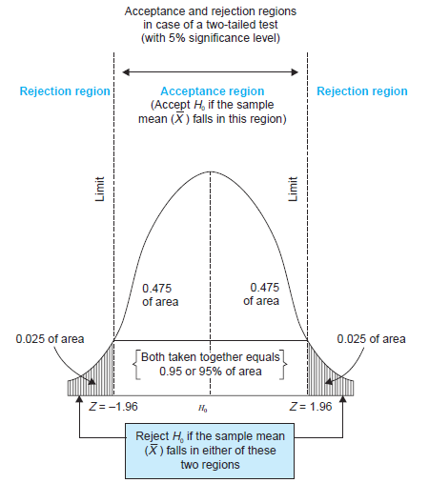



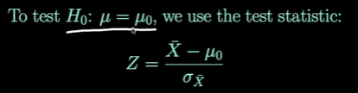

To test For Null Hypothesis, the population mean “u” is equal to some hypothesized value, we use z statisitic.


if Ho is true, the Z test statistic will have the standard normal distribution.

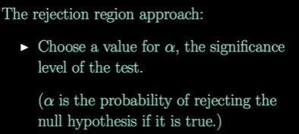

People choose Alpha =0.05



Find the appropriate rejection region which depends on our choice of alpha and alternative hypothesis.
Reject the null hypothesis if the test statistic falls in the rejection region.

